
AP Biology
Unit 3: Cellular Energetics
Suggested Duration: 12 Days
CELLULAR ENERGETICS
UNIT PLAN

Table of Contents
UNIT NARRATIVE 1
CONTENT STANDARDS 2
ROADMAP 4
UNPACKED STANDARDS 15
VOCABULARY GLOSSARY 17

UNIT NARRATIVE
In this unit, students build on knowledge gained in unit 3 about the structure and function of cells, focusing on cellular energetics. Living systems are complex in their organization and require constant energy input. This unit will provide students with the knowledge necessary to master the concepts of energy capture and use. Students work through enzyme structure and function, learning the ways in which the environment plays a role in how enzymes perform their functions. Students gain a deeper understanding of the processes of photosynthesis and cellular respiration, knowledge they will use in later units while studying how cells use energy to fuel life processes. Students often lack an understanding of metabolic pathways, confusing them with other processes. Students should know inputs and outputs of metabolic pathways, predict how changes in reactants affect them, and explain how organisms and ecosystems are affected by changes. Common misconceptions include only animals conduct cellular respiration, oxygen is created during photosynthesis, and only plants conduct photosynthesis. Be sure to make clear the distinction between memorizing molecules and demonstrating an understanding of how molecular events connect to overall functions of organisms and to carbon transfer within ecosystems. Students should understand cellular respiration and photosynthesis to predict and justify the effect of environmental changes on those processes. Students may be required to graph data from an experiment, using the skills learned in previous units, and calculate reaction rates. Students are advised to show their calculations, ensuring that units are included in their final answer.

Focus on Digital Literacy: In Science, disciplinary literacy is synonymous with the science and engineering practices. The SEPs are the context through which all science concepts should be taught. In the lessons, you will find the science and engineering practice icons.









UNDERTANDINGS AND CONTENT STANDARDS
Below are the standards taught and assessed in this unit.
Topic
- Big Idea
  - Learning Objectives (Students will be able to…)
Topic 3.1 – Enzymes
- Big Idea 2: Energetics – Biological systems use energy and molecular building blocks to grow, reproduce, and maintain dynamic homeostasis.
  - 3.1.A: Explain how enzymes affect the rate of biological reactions.

Topic 3.2 – Environmental Impacts on Enzyme Function
- Big Idea 2: Energetics – Biological systems use energy and molecular building blocks to grow, reproduce, and maintain dynamic homeostasis.
  - 3.2.A: Explain how changes to the structure of an enzyme may affect its function.
  - 3.2.B: Explain how the cellular environment affects enzyme activity.

Topic 3.3 – Cellular Energy
- Big Idea 2: Energetics – Biological systems use energy and molecular building blocks to grow, reproduce, and maintain dynamic homeostasis.
  - 3.3.A: Describe the role of energy in living organisms.
  - 3.3.B: Explain how shared, conserved, and fundamental processes and features support the concept of common ancestry for all organisms.

Topic 3.4 – Photosynthesis
- Big Idea 2: Energetics – Biological systems use energy and molecular building blocks to grow, reproduce, and maintain dynamic homeostasis.
  - 3.4.A: Describe the photosynthetic processes and structural features of the chloroplast that allow organisms to capture and store energy.
  - 3.4.B: Explain how cells capture energy from light and transfer it to biological molecules for storage and use.

Topic 3.5 – Cellular Respiration
- Big Idea 2: Energetics – Biological systems use energy and molecular building blocks to grow, reproduce, and maintain dynamic homeostasis.
  - 3.5.A: Describe the processes and structural features of mitochondria that allow organisms to use energy stored in biological macromolecules.
  - 3.5.B: Explain how cells obtain energy from biological macromolecules in order to power cellular functions.

Topic 8.2 – Energy Flow Through Ecosystems
- Big Idea 2: Energetics – Biological systems use energy and molecular building blocks to grow, reproduce, and maintain dynamic homeostasis.
  - 8.2.B: Explain how energy flows and matter cycles through trophic levels.
Key Questions
- What are enzymes made up of?
- What are the properties of enzymes?
- How are the active site and the substrate related to each other?
- How does an enzyme speed up a reaction?
- Why would changing the structure of a biological molecule change its function?
- What types of environmental factors are able to affect the rate of enzyme catalysis?
- What is the role of energy in living organisms?
- What crucial events occur in the light-dependent reactions? Why are these important to the process of photosynthesis?
- What crucial events occur in light-independent reactions? Why are these important to the process of photosynthesis?
- What types of environmental factors are able to affect the rate of photosynthesis?
- What crucial events occur in glycolysis? Why are these important to the process of cellular respiration?
- What crucial events occur in the Kreb’s Cycle? Why are these important to the process of cellular respiration?
- What crucial events occur in electron transport chain? Why are these important to the process of cellular respiration?
- What crucial events occur in glycolysis? Why are these important to the process of cellular respiration?
- What types of environmental factors are able to affect the rate of cellular respiration?
- What is the connection between variation in the number/types of cellular molecules and the ability of an organism to survive long enough to be able to reproduce?

ROADMAP
Suggested daily guide for instruction in this unit.

Lesson #1: Enzyme Structure and Function |  | Date:
Objective  SWBAT: Model an enzymatic reaction and explain why the structure of the enzyme is crucial to its function.  Standards  3.1.A: Explain how enzymes affect the rate of biological reactions.  3.2.A: Explain how changes to the structure of an enzyme may affect its function.  3.2.B: Explain how the cellular environment affects enzyme activity.  Vocabulary  Enzyme  Activation energy  Substrate  Active site  Competitive inhibition  Non-competitive inhibition  Reactant  product  Science Practices  Concept explanation  Visual representations | Instructional Notes  Students will participate in a Read to Learn activity that covers components of an enzymatic reaction, mechanism of that reaction, types of enzymes, and importance of enzymes in biological systems.  Then students will participate in a modeling activity using pool noodle enzyme models. Students will model how the enzyme connects to the substrate to become the enzyme-substrate complex which then catalyzes the reaction turning reactants into products. They will then model what happens to this reaction in the presence of competitive and non-competitive inhibitors.  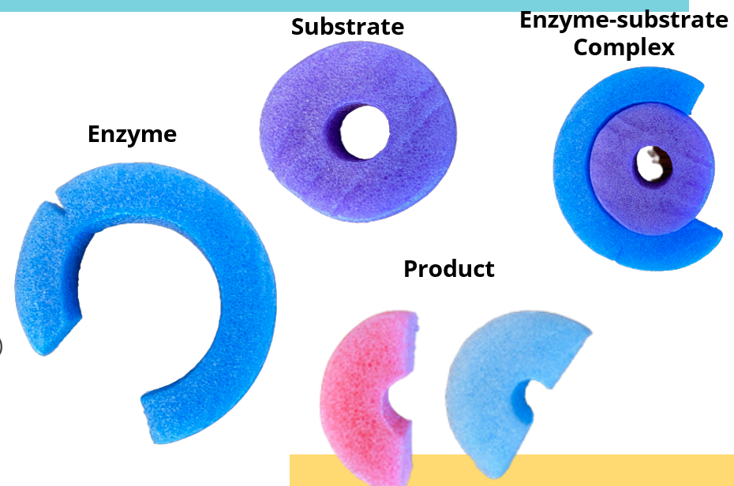  Students will then participate in a performance task called Cellulase. Students differentiate between the roles various macromolecules play in supporting cellular systems and demonstrate understanding of enzyme activity as they engage in model-based explanations. Finally, students illustrate their knowledge of experimental design as they analyze data and elaborate on further steps in a study on what influences cellulase reaction rates. |  | Lesson Look Fors  Look for teachers to:  - Allow students to productively struggle with the content, using accountable talk moves to facilitate the lesson.  - Teachers should be walking around the room ensuring that students are engaged in all activities correctly, consistently monitoring for incorrect biology.  Look for students to:  - Engage in the hands-on-minds-on modeling activity  - Ask clarifying questions regarding what they are learning  - Write in complete sentences  Students Do and Know
   | - Model an enzymatic reaction.  - Analyze a scenario to predict an outcome.  - Annotate a reading passage to better understand concepts.
   | - An enzyme is a protein.  - Enzymes speed up chemical reactions by lowering activation energy.  - An enzyme has an active site where the substrate is able to fit.  - Inhibitors act to eliminate an enzyme’s ability to catalyze a reaction.

Lesson #2: Gizmo Lab – Enzyme STEM Case |  | Date:
Objective  SWBAT: Investigate the structure/function of enzymes and predict the cause of illness due to enzyme deficiencies.  Standards  3.1.A: Explain how enzymes affect the rate of biological reactions.  3.2.A: Explain how changes to the structure of an enzyme may affect its function.  3.2.B: Explain how the cellular environment affects enzyme activity.  Vocabulary  Enzyme  chemical reactions  substrate  reactant  product  reaction rate  catabolism  catalysis  denaturation  Science Practices  - Visual representations  - Argumentation  - Data Analysis  - Construct Explanations | Instructional Notes  Students will participate in a Gizmos STEM Case involving a real-world application of enzymes. At the start of the case study students are introduced to their patient, Claire. Claire is a Great Dane who is experiencing rapid weight loss and lethargy even though she is eating a lot.    Working as a veterinary technician, students must examine Claire to determine the cause of her weight loss. Students then enter the Enzymes Handbook to learn the concepts they will need to solve the case and help Claire. The Handbook is an interactive guide that covers the key principles of enzymes. While in the Handbook students interact with a variety of scenarios each covering a different topic in enzymes. They also create and analyze graphs to prepare them to analyze Claire’s lab results. Once the Handbook is complete, students return to the case to collect data on Claire. They travel inside Claire’s stomach and small intestine to collect samples and take a closer look at pepsin, protease, carbohydrase, and lipase. Next, they compare Claire’s samples to those of a healthy dog (a control) to discover if the problem is in her stomach or intestine. From there they research three possible causes: enzyme active site mutation, abnormal pH, or low enzyme production. Students then hypothesize which problem Claire is experiencing and perform an experiment for each possible cause. Students can revise their hypothesis after each experiment. At the conclusion of the case, students write a case summary to communicate their findings and practice scientific writing skills. |  | Lesson Look Fors  Look for teachers to:  - Teachers should be walking around the room during the Gizmo activity asking probing questions.  - Allow students to productively struggle with the content, using accountable talk moves to facilitate the lesson.  Look for students to:  - Engage in the online simulation and fill out the student document.  - Ask clarification questions regarding what they are learning.  - Writing in complete sentences  Students Do and Know
  - Interact with online case study and answer questions regarding the concepts learned.
  - Investigate a hypothesis using quality experimental design.
  - Make conclusions based on data analysis.
  - Denaturation involves an environmental factor causing a structure change in an enzyme that causes the function to change.
  - Enzymes are proteins.
  - Metabolism is the sum total of all chemical reactions inside the body, and they are often “run” by enzymes.
  - Enzymes increase the reaction rate of chemical reactions.
  - In a chemical reaction, reactants are converted into products.
Lesson #3: Catalase Lab |  | Date:
Objective  SWBAT: Investigate the effect of different factors on catalysis rate..  Standards  3.1.A: Explain how enzymes affect the rate of biological reactions.  3.2.A: Explain how changes to the structure of an enzyme may affect its function.  3.2.B: Explain how the cellular environment affects enzyme activity.  Vocabulary  Enzyme  Chemical reaction  Substrate  Reactant  Product  Reaction rate  Kinetics  pH  substrate concentration  temperature  Science Practices  - Construct Explanations  - Argumentations  - Visual representations  - Questions and Methods | Instructional Notes  Background: Enzymes work to speed up biological reactions by lowering their activation energy. There are certain conditions that must be met for an enzyme to work efficiently: substrate concentration, temperature, and pH.  Background: For this activity, you will be investigating the response of potatoes to Hydrogen Peroxide, a common drugstore chemical. Cells use enzymes to assist them in performing processes that would otherwise move to slowly to be efficient. While enzyme structure is not the goal of this lab, the understanding of enzymes is essential for Biology.  The goal today is to perform an experiment and begin to understand why scientists use statistics to analyze the data they collect. As you follow the procedure, keep a list of observations and gather data continually.  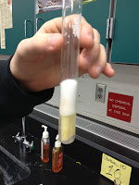 |  | Lesson Look Fors  Look for teachers to:  - Allow students to productively struggle with the content, using accountable talk moves to facilitate the lesson.  - Teachers should be walking around the room ensuring that students are engaged in all activities correctly, consistently monitoring for incorrect biology.  Look for students to:  - Engage in the hands-on-minds-on modeling activity  - Ask clarifying questions regarding what they are learning  - Write in complete sentences  Students Do and Know
  - Perform an experiment to test the factors that affect catalysis rates.
  - Use CER to defend their results.
  - Enzymes function in specific environmental conditions.
  - Factors that affect enzyme rates are enzyme and substrate concentration, temperature, pH, etc.

Lesson #4: Photosynthesis Activity |  | Date:
Objective  SWBAT: Describe how the light-dependent and light-independent reactions work together to create carbohydrates.  Standards  3.3.A: Describe the role of energy in living organisms.  3.3.B: Explain how shared, conserved, and fundamental processes and features support the concept of common ancestry for all organisms.  3.4.A: Describe the photosynthetic processes and structural features of the chloroplast that allow organisms to capture and store energy.  3.4.B: Explain how cells capture energy from light and transfer it to biological molecules for storage and use.  Vocabulary  Photosynthesis  Photosystem I  Photosystem II  Chloroplast  Electrons  Calvin Cycle  Carbon dioxide  Water  Glucose  oxygen  Science Practices  Construct explanations  Visual representations  Argumentation | Instructional Notes  Students will engage in an interactive animation from Biointeractive. As they watch the animation, they will fill out the thought catcher. You can either project the animation at the front of the room and watch it together, or you can have individual groups watch it on their own device.  This multipart animation series explores the process of photosynthesis and the structures that carry it out.  Photosynthesis converts light energy from the sun into chemical energy stored in organic molecules, which are used to build the cells of many producers and ultimately fuel ecosystems. After providing an overview of photosynthesis, these animations zoom inside the cells of a leaf and into a chloroplast to see where and how the reactions of photosynthesis happen. The animations detail both the light reactions and the Calvin cycle, focusing on the flow of energy and the cycling of matter.  This animation series contains seven parts, which can be watched individually or in sequence. The first three parts are appropriate for middle school through college-level students. The remaining parts are appropriate for high school through college-level students; Parts 5 and 6 are recommended for more advanced students. Depending on students’ background, it may be helpful to pause the animations at various points to discuss different steps or structures. |  | Lesson Look Fors  Look for teachers to:  - Ensure students fill out their thought catcher while they are viewing the animation, not afterwards.  - Allow students to have some productive struggle, making them rewatch a portion of the animation if they need to.  Look for students to:  - Be very descriptive in their answers to the thought catcher’s prompts  - Write in complete sentences when appropriate  Students Do and Know
  - Analyzing an animation of the photosynthetic process and deriving meaning from its constituent parts.
  - Labeling and describing models
  - The light-dependent reactions take light energy and convert it to chemical energy in the form of NADPH and ATP.
  - The light-independent reaction (Calvin Cycle) utilizes the ATP and NADPH from the light reaction to convert carbon dioxide and some carbon-containing compounds and produce sugar molecules.
  - The light reactions utilize electron transport chains in order to produce ATP and NADPH.
  - Photosynthesis occurs in the chloroplast.

Lesson #5: Gizmo Lab – Photosynthesis |  | Date:
Objective  SWBAT: Investigate a scenario to predict which step of photosynthesis is being affected.  Standards  3.3.A: Describe the role of energy in living organisms.  3.3.B: Explain how shared, conserved, and fundamental processes and features support the concept of common ancestry for all organisms.  3.4.A: Describe the photosynthetic processes and structural features of the chloroplast that allow organisms to capture and store energy.  3.4.B: Explain how cells capture energy from light and transfer it to biological molecules for storage and use.  Vocabulary  Photosynthesis  Limiting factor  Photosystem I and II  Thylakoid  ATP  NADPH  Calvin Cycle  Chlorophyll  Carbon dioxide  Oxygen  Wavelength  Glucose  Science Practices  - Visual representations  - Data analysis  - Constructing explanations | Instructional Notes  Lesson Summary: At the start of the case study students learn that the Great Barrier Reef is experiencing coral bleaching. Scientists in Australia have asked for their help to research the problem. Working as a Marine Biologist students must perform experiments to determine the cause of the bleaching. To start their research students enter the Photosynthesis Handbook. The Handbook is an interactive guide that covers the key principles of photosynthesis listed in the Learning Objectives section above. While in the Handbook students interact with a variety of content covering the steps in photosynthesis: Photosystems I & II, and the Calvin Cycle. Students complete assessments to help them connect the steps to the concentrations of ATP, NADPH and sugar. Note that detailed biochemistry is not included as the focus is on helping students spot patterns in the data needed to solve the case.  Once the Handbook is complete, students return to the case to continue their research. They start by collecting and comparing data from a control aquarium that contains normal sea water to the data from an aquarium that contains Great Barrier Reef sea water. Next students interpret the data to hypothesize which step in Photosynthesis is being inhibited in the Great Barrier Reef: Photosystem I (inhibited by paraquat, an herbicide), Photosystem II (inhibited by diuron, an algicide) or the Calvin Cycle (inhibited by high sea temperature). They then perform three experiments, one for each step, and are able to revise their hypothesis after each experiment.  Exit Ticket:  Students will participate in an exit ticket that assesses their understanding that photosynthesis is run by light energy that is being absorbed and utilized to run the light-dependent reactions. This may be used for your SWAM meeting as well. |  | Lesson Look Fors  Look for teachers to:  - Teachers should be walking around the room during the Gizmo activity asking probing questions.  - Allow students to productively struggle with the content, using accountable talk moves to facilitate the lesson.  Look for students to:  - Engage in the online lab and fill out the student document.  - Ask clarification questions regarding what they are learning.  - Writing in complete sentences  Students Do and Know
  - Interact with online case study and answer questions regarding the concepts learned.
  - Investigate a hypothesis using quality experimental design.
  - Make conclusions based on data analysis.
  - There are two phases of photosynthesis: light dependent and light independent (Calvin Cycle).
  - Photosynthesis occurs in the chloroplast.
  - Photosynthesis is carbon dioxide + water + light energy glucose + oxygen.
  - The light dependent reactions occur in the thylakoid.
  - The light independent reactions occur in the stroma.
  - ATP and NADPH are energy-rich molecules that power the Calvin Cycle.

Lesson #6: Photosynthesis Lab |  | Date:
Objective  SWBAT: Collect and analyze data regarding how different levels of carbon dioxide affect photosynthetic rate.  Standards  3.3.A: Describe the role of energy in living organisms.  3.3.B: Explain how shared, conserved, and fundamental processes and features support the concept of common ancestry for all organisms.  3.4.A: Describe the photosynthetic processes and structural features of the chloroplast that allow organisms to capture and store energy.  3.4.B: Explain how cells capture energy from light and transfer it to biological molecules for storage and use.  Vocabulary  Photosynthesis  Limiting factor  Photosystem I and II  Thylakoid  ATP  NADPH  Calvin Cycle  Chlorophyll  Carbon dioxide  Oxygen  Wavelength  Glucose  Science Practices  Visual representations  Questions and methods  Representing and describing data  Statistical tests and data analysis  Argumentation | Instructional Notes  ABOUT THIS LESSON  This activity involves a review of the process of photosynthesis and the factors that affect that process. Students are asked to create a floating leaf disk assay to ascertain if photosynthesis  has occurred. Upon completion, the students are asked to investigate another factor that might influence photosynthetic activity.  OBJECTIVES  Students will:  - Follow a procedure to determine the effect of baking soda (sodium bicarbonate), CO_{2,} on the process of photosynthesis  - Conduct an experiment that investigates another factor that might affect the rate of photosynthesis  - Create a mini poster to communicate their results to peers that illustrates the factor that was investigated.  Students are given a guided practice investigating the effect of adding sodium bicarbonate to a water/soap solution, which will allow the leaf disks to absorb carbon dioxide from the water and give off oxygen as a byproduct that causes the disks to float.  It is necessary to prepare a sodium bicarbonate solution for the students. To prepare 500 mL of the solution, add 2 g baking soda to 500 mL of distilled water.  You must have fairly new syringes to make sure there is a tight seal, or a vacuum will not be created. When you pull the plunger out of the syringe quickly, it should make a large popping sound. Demonstrate to your students how to make the vacuum by pulling the syringe all the way back while stopping the pointed end with your thumb. |  | Lesson Look Fors  Look for teachers to:  - Allow students to productively struggle with the content, using accountable talk moves to facilitate the lesson.  - Teachers should be walking around the room ensuring that students are engaged in all activities correctly, consistently monitoring for incorrect biology.  Look for students to:  - Engage in the hands-on-minds-on modeling activity  - Ask clarifying questions regarding what they are learning  - Write in complete sentences  Students Do and Know
  - Follow the written procedure for the inquiry lab.
  - Create a poster that will be shared with the student’s peers.
  - Measure the effect of different environmental factors on the rate of photosynthesis.
  - Environmental factors (independent variables) that affect photosynthetic rate are light intensity, color of light, amount of available CO₂, temperature, and pH.
  - Possible dependent variables in future investigations could be buildup of oxygen, depletion of carbon dioxide, and buildup of glucose.
Lesson #7: Cellular Respiration Modeling |  | Date:
Objective  SWBAT: Create a model that shows the relationships involved in the process of cellular respiration.  Standards  3.3.A: Describe the role of energy in living organisms.  3.3.B: Explain how shared, conserved, and fundamental processes and features support the concept of common ancestry for all organisms.  3.5.A: Describe the processes and structural features of mitochondria that allow organisms to use energy stored in biological macromolecules.  3.5.B: Explain how cells obtain energy from biological macromolecules in order to power cellular functions.  Vocabulary  mitochondria  ATP  ATP synthase  cell respiration  aerobic respiration  anaerobic respiration  Science Practices  - Questions and Methods  - Data Analysis  - Constructing explanations | Instructional Notes  Students watch a video on cellular respiration (aerobic vs anaerobic). The students can either take notes before the card sort OR do the card sort AS they watch the video.  Then students will participate in a card sort. It is imperative that you allow students to produce their own models, i.e., there are multiple ways in which students can find relationships among the different cards. The important thing is that they create their own models of how they fit together and then be able to communicate to others why they created the models that they did. You will need to cut these cards out before class and have them ready for each student (or student group).  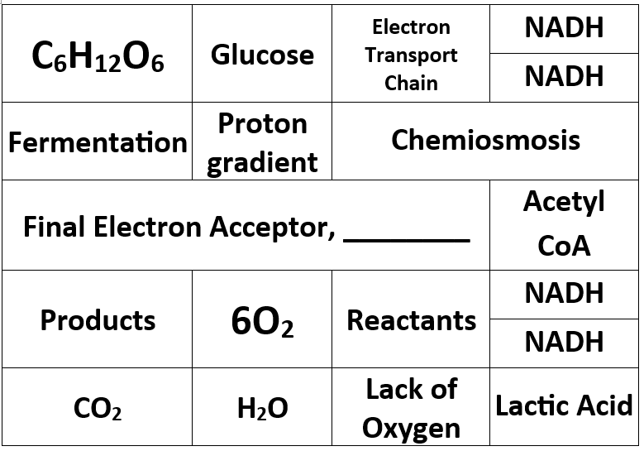  Then, students will have an opportunity to apply what they have learned by crafting a written response involving the purpose/process of cellular respiration, as well as analyzing a graph. |  | Lesson Look Fors  Look for teachers to:  - Teachers should be walking around the room during the Gizmo activity asking probing questions.  - Allow students to productively struggle with the content, using accountable talk moves to facilitate the lesson.  Look for students to:  - Engage in the online simulation and fill out the student document.  - Ask clarification questions regarding what they are learning.  - Writing in complete sentences  Students Do and Know
  - Interact with online case study and answer questions regarding the concepts learned.
  - Investigate a hypothesis using quality experimental design.
  - Make conclusions based on data analysis.
  - Glycolysis is the splitting of glucose into 2 pyruvate, giving off 2 ATP.
  - The Kreb’s Cycle (Citric Acid Cycle) takes the pyruvate and gives off carbon dioxide, hydrogen ions, and 2 ATP.
  - The electron transport chain, where ATP synthase is, creates the most ATP (~32).

Lesson #8: Cellular Respiration Activity |  | Date:
Objective  SWBAT: Explain how energy flows through the three steps of cellular respiration.  Standards  3.3.A: Describe the role of energy in living organisms.  3.3.B: Explain how shared, conserved, and fundamental processes and features support the concept of common ancestry for all organisms.  3.5.A: Describe the processes and structural features of mitochondria that allow organisms to use energy stored in biological macromolecules.  3.5.B: Explain how cells obtain energy from biological macromolecules in order to power cellular functions.  Vocabulary  Cellular respiration  Glycolysis  Kreb’s Cycle (Citric Acid Cycle)  Electron transport chain  Aerobic respiration  Anaerobic respiration  Proton gradient (proton motive force)  Science Practices  Concept Explanation  Visual representations  Questions and Methods  Argumentation | Instructional Notes  Today students will practice their writing utilizing two free response questions that assesses content from unit 3 (and a little from unit 2).  A highlight and rewrite activity takes some time, but it is SO worth it! The students follow these directions:  - They are presented with a prompt (an AP Biology FRQ) and asked to write the best answer they can in the given time. The appropriate amount of time is 2.5 minutes for each “point.” Therefore for this question (worth 9 points) they should get 22.5 minutes.  - Then, they take the rubric by which the question was originally scored at the AP Biology Reading and with a highlighter, they “highlight” everywhere on their answer where the rubric states that they earned a point.  - Then, they analyze their answer (with the highlights) for where they earned points and where they didn’t earn points. They write down on the document their answers to questions such as: Why did I receive a point here? Why did I not receive a point here? Did I not earn this point because I didn’t know it, didn’t understand the question, or did I forget to add in something that I did know?  - Then the students will be presented with the question again. This time, taking what they now know, they write a perfect response. This might be tricky at first, i.e., to take the rubric and use it to write a perfect response, but it will truly revolutionize their ability to write like a biologist. |  | Lesson Look Fors  Look for teachers to:  - Circulate around the room ensuring that students are engaged in the highlight and rewrite (some will want to give up.)  - Allow for some productive struggle and not immediately swooping in and help them.  Look for students to:  - Give the first attempt a really solid try, not just waiting on the rubric to help them out. Some productive struggle here will be good for them.  - Analyzing their own answer to identify glows and grows.  - Really putting in some effort on the “rewrite” portion of the assignment in order to craft a perfect response.  Students Do and Know
  - Construct a response to a prompt with multiple questions associated with it.
  - Identify the different components of quality experimental design
  - Justify a prediction and/or claim
  - Glycolysis breaks down glucose into two pyruvate.
  - Kreb’s Cycle (Citric Acid Cycle) gives electrons to electron carriers (NAD⁺ and FAD⁺) and they take them to the electron transport chain.
  - The electron transport chain produces enough energy to force protons through the inner membrane and when the protons fall back through ATP synthase, ATP produced.
  - Anaerobic respiration occurs in the absence of oxygen.
  - Energy flow through cellular respiration: glucose NADH electron transport chain proton-motive force ATP
Lesson #9: Cellular Respiration Lab |  | Date:
Objective  SWBAT: Analyze a student-designed experiment for the effect of an environmental factor that might affect cellular respiration.  Standards  3.3.A: Describe the role of energy in living organisms.  3.3.B: Explain how shared, conserved, and fundamental processes and features support the concept of common ancestry for all organisms.  3.5.A: Describe the processes and structural features of mitochondria that allow organisms to use energy stored in biological macromolecules.  3.5.B: Explain how cells obtain energy from biological macromolecules in order to power cellular functions.  Vocabulary  ATP  NADH  Cellular Respiration  Null hypothesis  Alternative hypothesis  Science Practices  Constructing explanations  Visual representations  Questions and methods  Representing and describing data  Statistical tests and data analysis  Argumentation | Instructional Notes  Students will engage in an open-inquiry lab called Cellular Respiration Accounting Model. Students will have access to a simulation that they are 100% in control of. They will ask an appropriate scientific question, make a hypothesis, design their data collecting protocol, and then run their experiment. The simulation has a graph that keeps up with each “run” that they do.  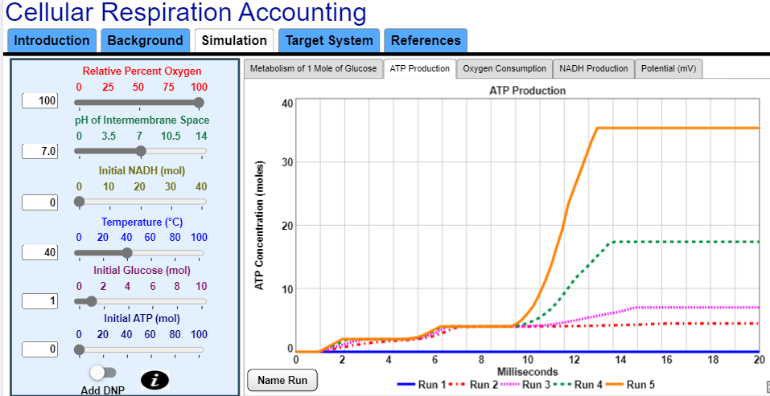  Students will do the following:  - Produce a question that they would like to answer. What is the effect of temperature on ATP production during cellular respiration?  - They will make both a null and an alternative hypothesis. (NH) Temperature will have no effect on ATP production. (AH) With increased temperature, the ATP produced will increase.  - They will design an experiment. Students list out the steps they will take (how they will manipulate the simulation) in order to run their experiment.  - They will analyze their results by recreating the data on the screen on their own paper.  - They will then make a conclusion and support it with evidence and explanation. I support/reject my hypothesis that stated…, the graph shows that ATP steadily increased with increased temperature until 50 degrees where it dipped back down due to enzymes being denatured. |  | Lesson Look Fors  Look for teachers to:  - Allow students to productively struggle with the content, using accountable talk moves to facilitate the lesson.  - Teachers should be walking around the room ensuring that students are engaged in all activities correctly, consistently monitoring for incorrect biology.  Look for students to:  - Engage in the hands-on-minds-on modeling activity  - Ask clarifying questions regarding what they are learning  - Write in complete sentences  Students Do and Know
  - Design an experiment to test the effect of a certain independent variable on a dependent variable.
  - Analyze a graph for trends and then make a conclusion that is backed with evidence.
  - There are several factors that can have an effect on the rate of cellular respiration, such as carbon dioxide accumulation, oxygen production, and ATP production.
  - The equation for cellular respiration is:
  C₆H₁₂O₆ + 6O₂ 6CO₂ + 6H₂0 + ATP (energy)

Lesson #10: Making Connections |  | Date:
Objective  SWBAT: Investigate how carbon cycles through trophic levels and how disruptions impact ecosystem balance.  Standards  8.2.B: Explain how energy flows and matter cycles through trophic levels.  Vocabulary  Carbon cycle  Photosynthesis  Cellular respiration  Decomposition  Combustion  Reservoir  Biogeochemical cycle  Autotroph  Heterotroph  Decomposer  Atmospheric CO₂  Carbon sequestration  Organic carbon  Inorganic carbon  Fossil fuels  Greenhouse gases  Ecosystem  Matter cycling  Energy flow  Abiotic factors  Biotic factors  Climate change  Homeostasis (in ecosystems)  Science Practices  1, 2, 4, and 6 | Instructional Notes  The Carbon Cycle Investigation is a two-part activity model for the carbon cycle through analysis and hands-on learning.  - Activity #1: In Part I, students complete a QR Code Gallery Walk to explore how carbon moves through ecosystems.  - Activity #2: In Part II, they construct a closed mesocosm using soil, pinto beans, and gravel to observe carbon-related processes over time. The goal is to reinforce AP Biology concepts on matter cycling and energy flow through real-world modeling and data collection. Teachers should introduce the activity by connecting carbon cycling to climate and ecosystem stability.  This lesson includes some pre-work that students is highly encouraged to do prior to arriving in class on this day.  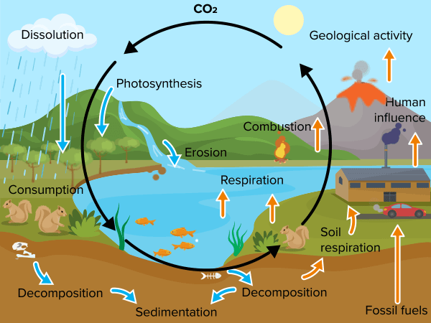 |  | Lesson Look Fors  Look for teachers to:  - Circulate to check for accurate, complete responses; ask guiding questions like “Is this step biotic or abiotic?”  - Checking for misconceptions (listed in lesson plan)  Look for students to:  - Utilize all available resources in order to find a connection without giving up and moving on  Students Do and Know
  - Work with a group to find connections between/among a number of biological concepts
  - Cellular respiration is the process by which mitochondria take glucose and oxygen and create usable energy in the form of ATP.
  - The carbon cycle is the continuous movement of carbon atoms between the Earth’s atmosphere, oceans, land, and living organisms.
  - In an ecosystem, energy flows while matter cycles. Energy enters as sunlight, is converted into chemical energy by producers (photosynthesis), and then transferred through trophic levels, eventually being lost as heat. Matter, on the other hand, is continuously recycled within the ecosystem, moving between living organisms and the non-living environment.

Day 11 | Review Day
Day 12 | Administer UE3

UNPACKED STANDARDS
Focus standards for this unit.

Standards Clarification
Standards | Specificity | Suggested Skills
3.1.A: Explain how enzymes affect the rate of biological reactions. | Cognition: Explain  Content: Provide information about how or why a relationship, process, pattern, position, situation, or outcome occurs, using evidence and/or reasoning to support or qualify a claim. Explain “how” typically requires analyzing the relationship, process, pattern, position, situation, or outcome; whereas explain “why” typically requires analysis of motivations or reasons for the relationship, process, pattern, position, situation, or outcome. | Conceptual Explanation (SP 1.B)  Explain biological concepts and/or processes
3.2.A: Explain how changes to the structure of an enzyme may affect its function. |  | Questions and Methods (SP 3.C.b)  Identify experimental procedures that are aligned to the question, including identifying appropriate controls.  Questions and Methods (SP 3.C.c)  Identify experimental procedures that are aligned to the question, including justifying appropriate controls
3.2.B: Explain how the cellular environment affects enzyme activity. |  | Argumentation (SP 6.E.c)  Predict the causes or effects of a change in, or disruption to, one or more components in a biological system based on data.  Resources:  AP Biology Lab Manual – Enzyme Lab  Classroom Resources – Visualizing Information
3.3.A: Describe the role of energy in living organisms. | Cognition: Describe  Content: Provide relevant characteristics of a specified topic. | Argumentation (SP 6.C)  Provide reasoning to justify a claim by connecting evidence to biological theories.
3.3.B: Explain how shared, conserved, and fundamental processes and features support the concept of common ancestry for all organisms. | Cognition: Explain  Content: Provide information about how or why a relationship, process, pattern, position, situation, or outcome occurs, using evidence and/or reasoning to support or qualify a claim. Explain “how” typically requires analyzing the relationship, process, pattern, position, situation, or outcome; whereas explain “why” typically requires analysis of motivations or reasons for the relationship, process, pattern, position, situation, or outcome.
3.4.A: Describe the photosynthetic processes and structural features of the chloroplast that allow organisms to capture and store energy. | Cognition: Describe  Content: Provide relevant characteristics of a specified topic. | Resources:  AP Biology Lab Manual – Photosynthesis Lab  Classroom Resources – Visualizing Information  AVAILABLE RESOURCES  AP Central > AP Biology Lab Manual > Photosynthesis Lab  AP Central > Classroom Resources > Visualizing Information
3.4.B: Explain how cells capture energy from light and transfer it to biological molecules for storage and use. | Cognition: Explain  Content: Provide information about how or why a relationship, process, pattern, position, situation, or outcome occurs, using evidence and/or reasoning to support or qualify a claim. Explain “how” typically requires analyzing the relationship, process, pattern, position, situation, or outcome; whereas explain “why” typically requires analysis of motivations or reasons for the relationship, process, pattern, position, situation, or outcome.
3.5.A: Describe the processes and structural features of mitochondria that allow organisms to use energy stored in biological macromolecules. | Cognition: Describe  Content: Provide relevant characteristics of a specified topic. | Representing and Describing Data (SP 4.A)  Resources:  AP Biology Lab Manual – Cellular Respiration Lab  Classroom Resources – Visualizing Information
3.5.B: Explain how cells obtain energy from biological macromolecules in order to power cellular functions. | Cognition: Explain  Content: Provide information about how or why a relationship, process, pattern, position, situation, or outcome occurs, using evidence and/or reasoning to support or qualify a claim. Explain “how” typically requires analyzing the relationship, process, pattern, position, situation, or outcome; whereas explain “why” typically requires analysis of motivations or reasons for the relationship, process, pattern, position, situation, or outcome.
8.2.B: Explain how energy flows and matter cycles through trophic levels. |  | Argumentation (SP 6.D) – Explain the relationship between experimental results and larger biological concepts, processes, or theories.  AVAILABLE RESOURCES  - AP Central > AP Biology Lab Manual > Energy Dynamics Lab  - AP Central > Classroom Resources > Visualizing Information  ILLUSTRATIVE EXAMPLES  EK 8.2.C.1  - Food chains/webs  - Trophic pyramids/

VOCABULARY GLOSSARY
Domain-specific words and definitions for this unit.
Key Content Vocabulary
Active Site – refers to the specific region of an enzyme where a substrate binds, and catalysis takes place or where chemical reaction occurs.

Aerobic Respiration – set of metabolic reactions and processes that take place in the cells of organisms to convert chemical energy from oxygen molecules or nutrients into adenosine triphosphate (ATP) and then release waste products.

Anabolic – The series of chemical reactions that construct or synthesize molecules from smaller units, usually requiring input of energy (ATP) in the process.

Anaerobic – Not requiring, or capable of occurring, in the absence of air or free oxygen.

ATP – adenosine triphosphate

Calvin cycle – A cyclical series of biochemical reactions that occur in the stroma of chloroplasts during photosynthesis. It includes the light-independent reactions such as carbon fixation, reduction reactions and ribulose 1,5-diphosphate (RuDP) whereby sugars and starch are ultimately produced.

Carbon Fixation – process by which photosynthetic organisms such as plants turn inorganic carbon (usually carbon dioxide) into organic compounds (us. Carbohydrates).

Chemiosmosis – refers to the process of moving ions (e.g., protons) to the other side of the membrane resulting in the generation of an electrochemical gradient that can be used to drive ATP synthesis.

Chlorophyll – The green pigment found in the chloroplasts of higher plants and in cells of photosynthetic microorganisms (e.g., photosynthetic bacteria), which is primarily involved in absorbing light energy for photosynthesis

Chloroplast – refers to the organelle found within the cell of plants and other photosynthetic eukaryotes that is filled with the green pigment called chlorophyll.

coupled reactions – chemical reaction with a common intermediate in which energy is transferred from one side of the reaction to the other. An example is the formation of ATP, which is an endergonic process and is coupled to the dissipation of a proton gradient.

electrochemical gradient – a gradient of electrochemical potential, usually for an ion that can move across a membrane. The gradient consists of two parts, the chemical gradient, or difference in solute concentration across a membrane, and the electrical gradient, or difference in charge across a membrane.

electron transport chain – A group of compounds that pass electron from one to another via redox reactions coupled with the transfer of proton across a membrane to create a proton gradient that drives ATP synthesis

Energy – The ability to do work or produce change.

Enzyme – A biomolecule that acts as catalyst to speed up specific chemical reactions. Enzymes are either proteins or RNA (ribozymes) molecules.

ethyl alcohol – grain alcohol, made from sugar, starch and other carbohydrates by fermentation

FAD – FAD acts as an oxidizing agent. One of the most crucial reactions FAD is involved with is in the citric acid cycle. Succinate dehydrogenase is an enzyme that oxidizes succinate to be converted into fumarate by coupling it with the reduction of ubiquinone to ubiquinol. The electrons from the oxidation are stored transiently by the reduction of FAD to FADH₂. FADH₂ reverts to FAD by sending two electrons through the electron transport chain.

Fermentation – breaking down of sugar molecules into simpler compounds to produce substances that can be used in making chemical energy. Chemical energy, typically in the form of ATP, is important as it drives various biological processes. Fermentation does not use oxygen; thus, it is “anaerobic.”

Free Energy – The energy available to do work

Glycolysis – The initial metabolic pathway of cellular respiration in which a series of reactions happening in the cytosol results in the conversion of a monosaccharide, often glucose, into pyruvate, and the concomitant production of a relatively small amount of high-energy biomolecule, such as ATP

Krebs cycle (citric acid cycle) – (1) A cycle of reactions catalyzed by enzymes in which pyruvate derived from nutrients and converted to Acetyl Coenzyme A is completely oxidized and broken down into carbon dioxide and water to produce high-energy phosphate compounds, which are the source of cellular energy. (2) One of the major metabolic pathways of cellular respiration and involves a cyclic series of enzymatic reactions by which pyruvate converted into Acetyl Coenzyme A is completely oxidized to CO2 and hydrogen is removed from the carbon molecules, transferring the hydrogen atoms and electrons to electron-carrier molecules (e.g., NADH and FADH2) as well as the metabolic energy to high energy bonds (e.g., ATP).

lactic acid – An intermediate product of carbohydrate metabolism (anaerobic metabolism), derived chiefly from muscle cells and red blood cells.

Light-dependent reactions – The reaction taking place in the chloroplast in which the absorption of a photon leads to the formation of ATP and NADPH.

Light-independent reactions – See Calvin Cycle

NAD – a coenzyme involved in redox reactions; In metabolic reactions, nicotinamide adenine dinucleotide may be oxidized, NAD+, or reduced, NADH.

NADP – A coenzyme that serves as an electron carrier in a number of reactions, being alternately oxidized (NADP-) and reduced (NADPH).

oxidative phosphorylation – A metabolic pathway that generates ATP from ADP through phosphorylation that derives the energy from the oxidation of nutrients

Photolysis – The splitting or decomposition of a chemical compound by means of light energy or photons.

Photosynthesis – The synthesis of complex organic material using carbon dioxide, water, inorganic salts, and light energy (from sunlight) captured by light-absorbing pigments, such as chlorophyll and other accessory pigments.

Substrate – The substance acted upon by an enzyme.

